Task: To check details about the active users

command: id

Task: Show the last system logins

command: last

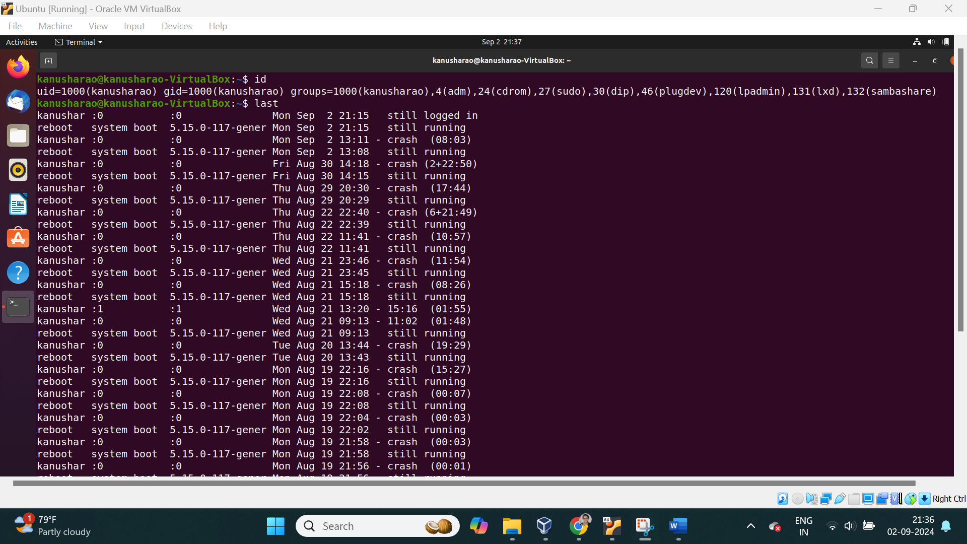

Task: To show failed login attempts

command: lastb

Task: Display who is currently logged into the system

command : who

Task: To Show which users are logged in and their activity

command: w

Task: To get user details from different text file like

/etc/passwd /etc/group/ etc/hosts and so on.

Command: getent nameofthefile username

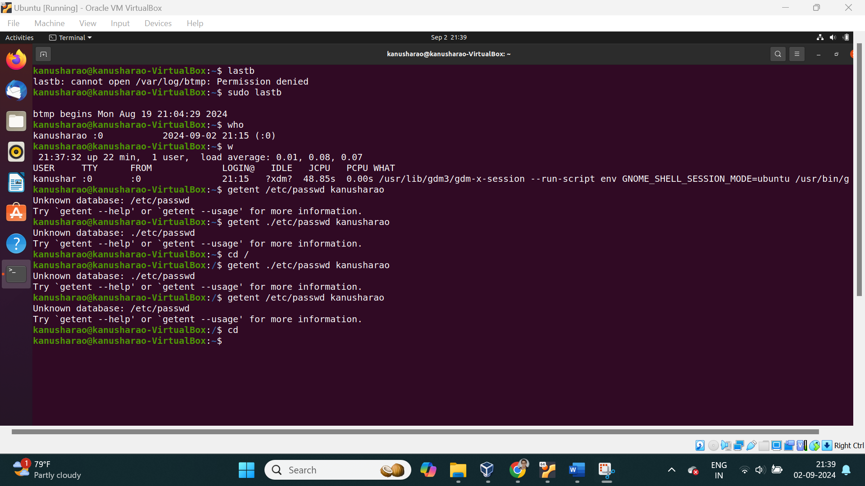

Task: To check user information

command: finger [user_name]

Task: Temporarily elevate user privileges to superuser (Super user do)

Command: sudo [command]

Task: To check the privilege of the user in configuration file

command visudo

Task: To Switch the user account or become a superuser

Command: su - [user_name]

Task: To change the user name and other details

command: chfn [user_name]

Task: To change the user login shell path

command: chsh -s [shell path] [username]

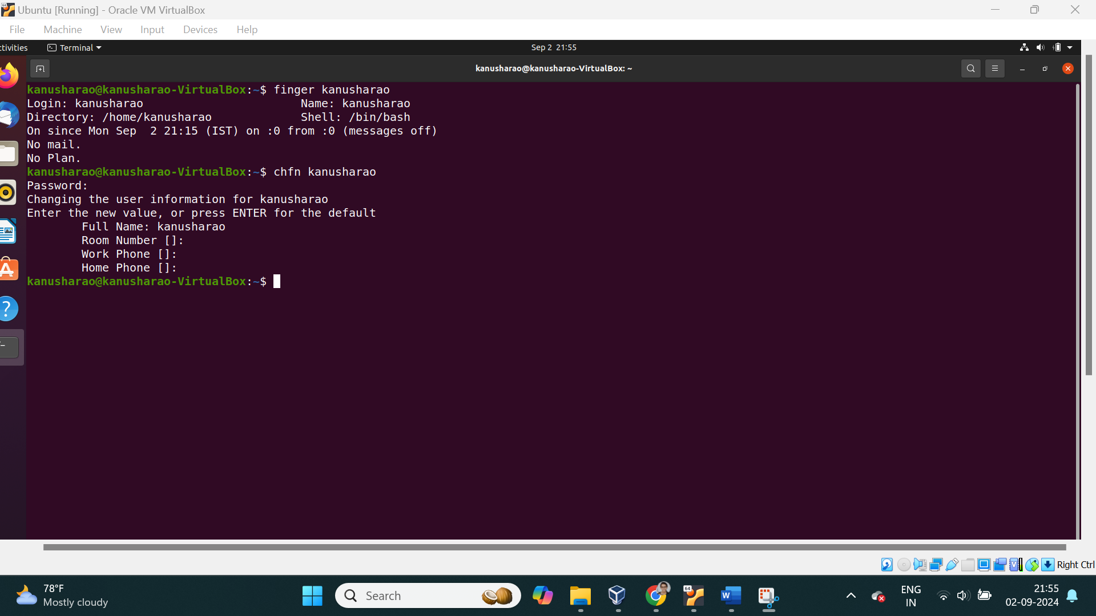

Task:

==============

User creation

==============

Task: To Create a new user account

command: sudo useradd [user_name]

adduser [user_name] depends upon the package

Task:To Delete a user account

Command: sudo userdel [user_name]

deluser [user_name]

Task: Modify user information or (add a user to a group).

Command: sudo usermod -aG [group_name] [user_name]

Task: To change the current user's password or another user's password with the passwd command.

Command: sudo passwd [user_name]

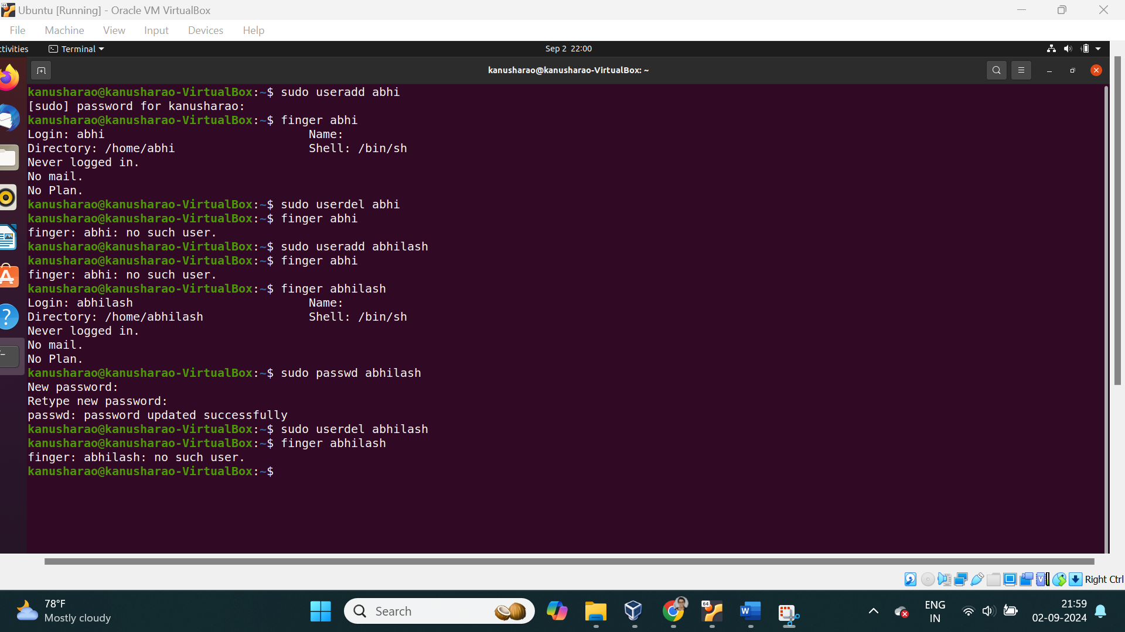

Task: To Add a new group.

Command: sudo groupadd [group_name]

Task: To Delete a group.

Command: sudo groupdel [group_name]

Task: To Modify a user group (change group name).

Command: sudo groupmod -n [new_name] [old_name]

Task: To Change file or directory group.

Command: chgrp [group_name] [file/directory]

Task: To change owner of the file

command: chown

Task: To List all user details (from 1000)

command: cat /etc/passwd

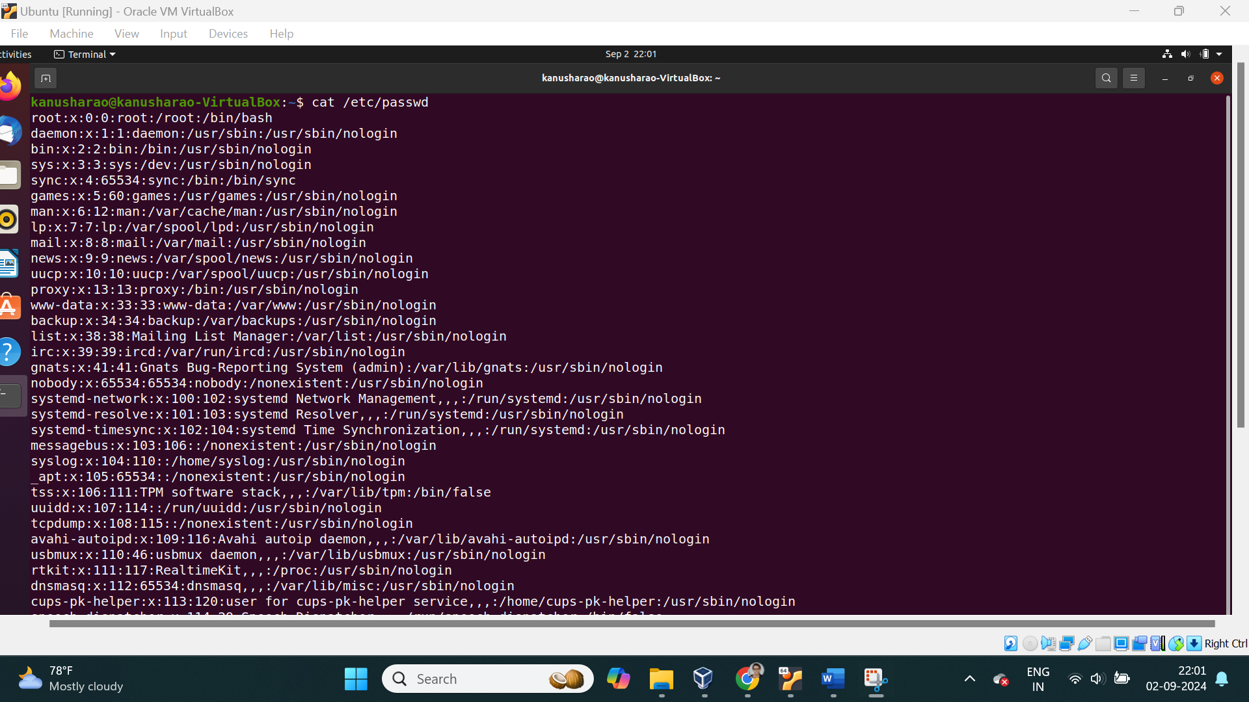

Task: To Print group names a user is in

command: groups

Task: To Print current login name

command: logname

=========

network

=========

ping

tnc

